Business Requirement (Project Requirement):
Create an ALV Interactive GRID Report, Smartform, Adobe form as per following requirement.

Selection Screen / Input Screen:
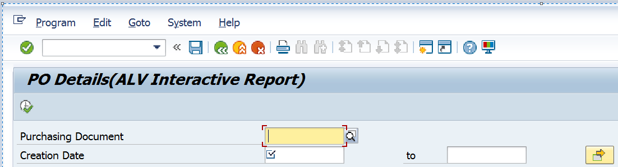

Table Fields for Reference:
PO Number = EKKO-EBELN
Creation Date = EKKO-AEDAT field should be mandatory.

Pls. Note:
- Do not use 'PARAMETERS' statement.
- Please create same to same selection screen as shown above.

ALV Output Screen:
Pls. Note: Use FM - REUSE_ALV_GRID_DISPLAY and manual fieldcatalog.
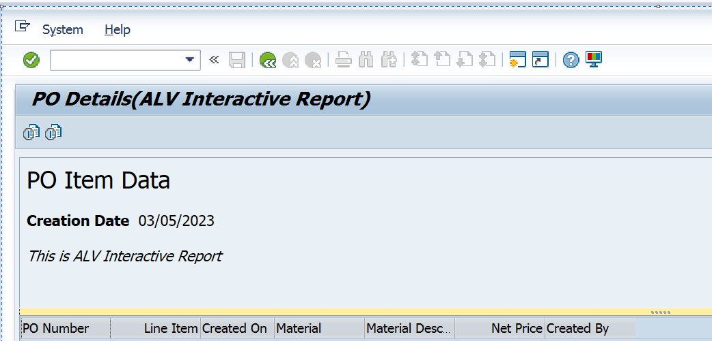
Output fields: Table and fields for reference:
PO Number = EKKO-EBELN
Line Item = EKPO-EBELP
Created On = EKKO-AEDAT
Material = EKPO-MATNR
Mat.Desc = MAKT-MAKTX
Net Price = EKPO-NETPR
Created By = EKKO-ERNAM

Imp point: Please ignore the data shown in the sample output, you need to display the data which is available in the system.

Pls. Note:
- Create two buttons in Application Toolbar (as shown below) with the help of PF Status.

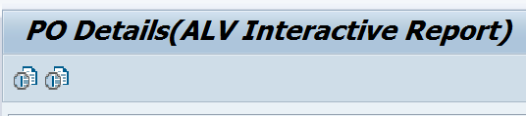

- Write following Page Header with the help of "TOP OF PAGE".
Hint: Call FM - REUSE_ALV_COMMENTARY_WRITE inside TOP OF PAGE subroutine.

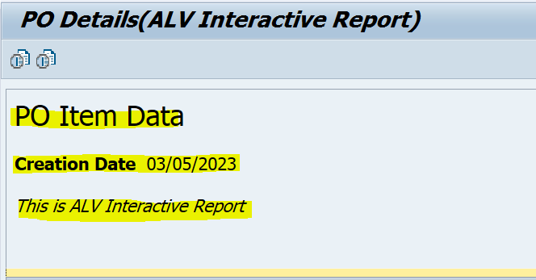

- Activate "BACK" button in Standard Toolbar inside PF Status. When user press this button, go back to Selection Screen.

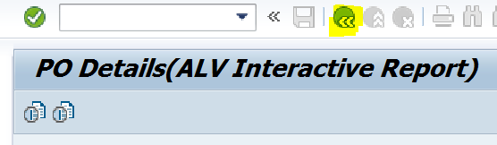

- Assign short key Shift+F1 to Ascending button, Shift+F2 to Descending button.

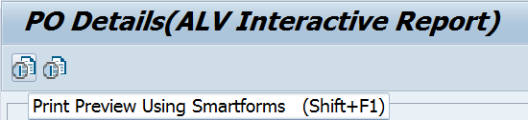

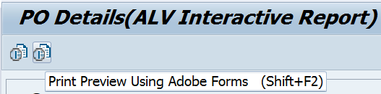

- When user press 1st button (Ascending) or Shift+F1 the output must display using smartforms, when user press 2nd button (Descending) or Shift+F1 the output must display using Adobe forms.

- When no data found for given inputs on selection screen, display message like following. When user press "Continue / Enter" button on message window, go back to selection screen.
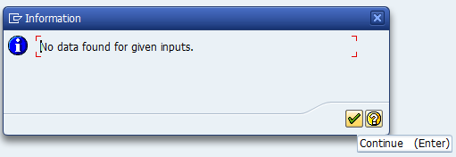

- Create a Transaction Code for your Program.

